**Importing The Necessary Libraries**

The first step is usually importing the libraries that will be needed in the program.

The required libraries to be imported to  Python script are:

**OpenCV:**

[OpenCV](https://en.wikipedia.org/wiki/OpenCV) is a library of programming functions mainly aimed at real-time computer vision. Here, OpenCV is used for resizing. Rescaling, thresholding the image.

**Imutils:**

Imutils package has a series of convenience functions to make basic image processing functions such as translation, rotation, resizing, and displaying Matplotlib images and video frames easier with OpenCV.

We will build_montages  for visualization. Our paths import will help us to extract the file paths to each of the images in our dataset.

**sklearn.metrics**:

The module implements several loss, score, and utility functions to measure classification performance.

**sklearn.preprocessing**:

This package provides several common utility functions and transformer classes to change raw feature vectors into a representation that is more suitable for the downstream estimators.

**Sklearn.ensemble**

This package contains RandomForestClassifier and many more inbuilt algorithms.

**Scikit-image**

Scikit-image, or skimage,  is an open-source Python package designed for image preprocessing.

Histogram of Oriented Gradients (HOG) will come from the feature import of scikit-image.

**Pickle:**

Python pickle module is used for serializing and de-serializing python object structures. The process to converts any kind of python objects (list, dict, etc.) into byte streams.

Now we will open spyder from the start menu.

All the above modules can be imported into our program using the below code

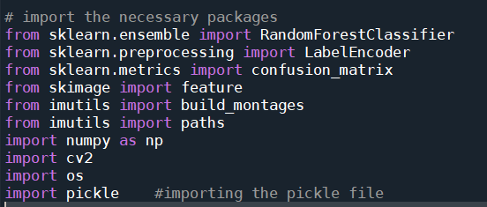

Once we have imported the packages we start loading the dataset.